Name ___________________________________________________
Date _____________
Block _____________

Daily Science Review
Score ______

- All matter is made of _________________________.
  - Cells
  - Protons
  - Elements
  - Atoms

- Elements are ____________________________.
  - Substances that cannot be broken down
  - Two or more substances combined
  - Two or more different substances combined
  - Smallest part of matter

- Compounds are ____________________________.
  - The smallest part of matter
  - Two or more substances combined
  - Two or more different substances combined
  - Substances that cannot be broken down

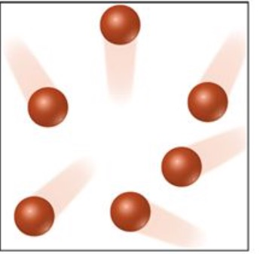
- The example to the right is a model of a single type of atom. What is this an example of?
  - Element
  - Compound
  - Molecule

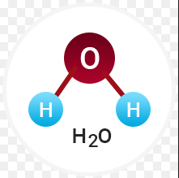
- Water (H2O) is made of two different elements combined. This an example of a(n)
  - Element
  - Compound
  - Molecule

