Preactivity text

Before we start our activity, complete the following:

Part 1:
Match the following measurements with their correct units by putting the letter of the measurement in the blank next to each unit:

- _______ meters

- _______ m/s

- _______ m

- _______ seconds

- _______ s

- _______ km

- _______ km/hr

- _______ m/s north

- _______ hr
- Distance
- Time
- Speed
- Velocity

What is acceleration?

Part 2:
Describe the motion of the object in the following graphs (Don’t worry about numbers: just think fast, slow, forwards, backwards…)
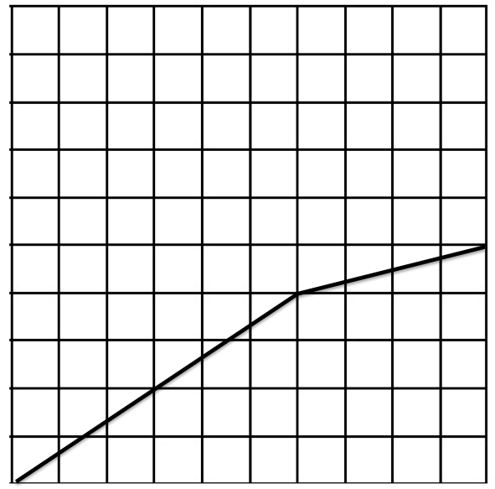
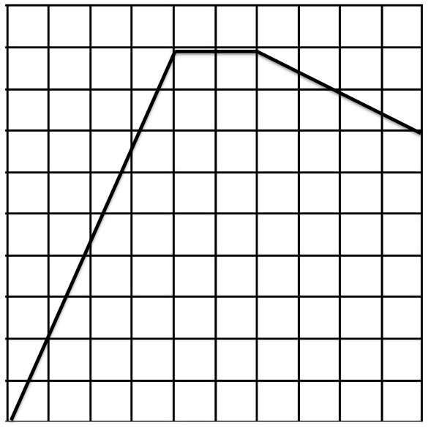

Time (seconds
Time (seconds
Figure 2: Distance vs. time of moving object B
Figure 1: Distance vs. time of moving object A
Distance (meters)
Distance (meters)

