Postactivity assessment

- Describe the motion of the object shown in each of the following Distance vs. Time graphs. Be sure to describe both speed and velocity (speed and direction).

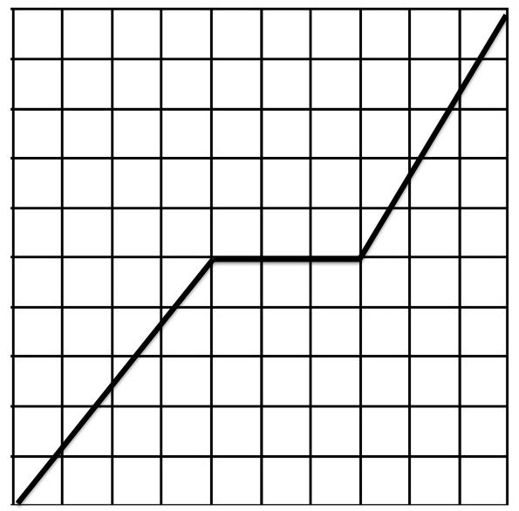
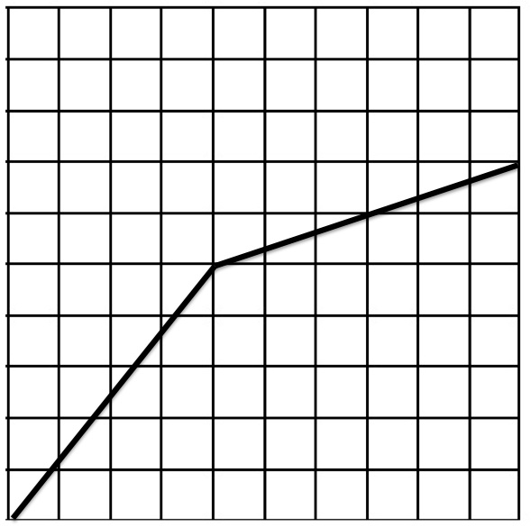
B.
A.

Time (seconds
Time (seconds

Distance (meters)
Distance (meters)
Figure 2: Distance vs. time of moving object B
Figure 1: Distance vs. time of moving object A

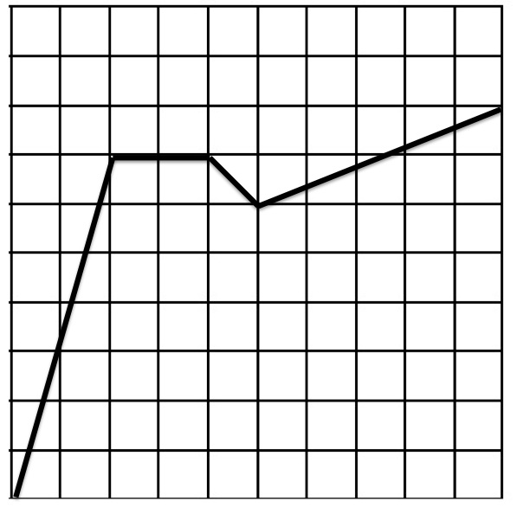
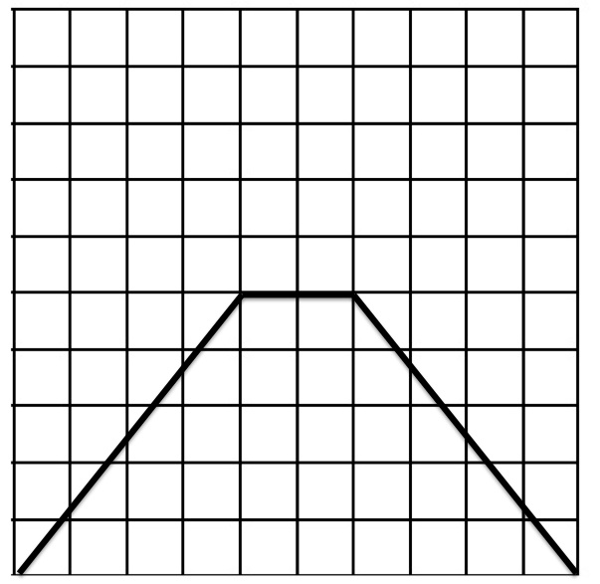
C.
D.

Time (seconds
Time (seconds

Distance (meters)
Distance (meters)
Figure 4: Distance vs. time of moving object D
Figure 3: Distance vs. time of moving object C

- Draw a velocity graph (distance vs. time) for the following scenarios. Be sure to add all required labels to your graphs.
A. A person looking for flowers in a field walks 25 meters in 15 seconds, stops to look closely at a flower for 15 seconds, and then walks on at the same speed for another 20 seconds.
B. A dog runs after a thrown ball for 40 meters in 10 seconds, stops for 2 seconds to pick up the ball, and then trots back to her owner in 20 seconds.

